Project Title: Infrared Receiver
Link: https://wiki.microduino.cc/index.php/Infrared_receiver

ORIGINAL:
Microduino-IR receiver is used to receive infrared signal from Infrared transmission. It can receive infrared signal within 10m.
EDIT:
The Microduino IR Receiver can receive infrared signals such as those used in remote control systems. Coupled with an infrared transmitter, the sensor adds remote control to any Microduino build.

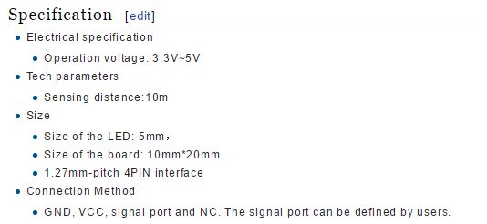

ORIGINAL:
- Electrical specification
  - Operation voltage: 3.3V~5V
- Tech parameters
  - Sensing distance:10m
- Size
  - Size of the LED: 5mm，
  - Size of the board: 10mm*20mm
  - 1.27mm-pitch 4PIN interface
- Connection Method
  - GND, VCC, signal port and NC. The signal port can be defined by users.

EDIT:
- Electrical Specifications
  - Operating Voltage: 3.3-5V
  - Input Device
- Technical Specifications
  - Sensing Range: 10 meters
  - Sensing Frequency: 38KHz
  - Receiving Angle: 45 Degrees
- Dimensions
  - LED: 5mm
  - Sensor Board: 10mm x 20mm
  - Interface: 4-Pin, 1.27mm pitch
- Connection Interface
  - Pins: Signal, VCC (power), GND (ground) and NC (Not Connected)

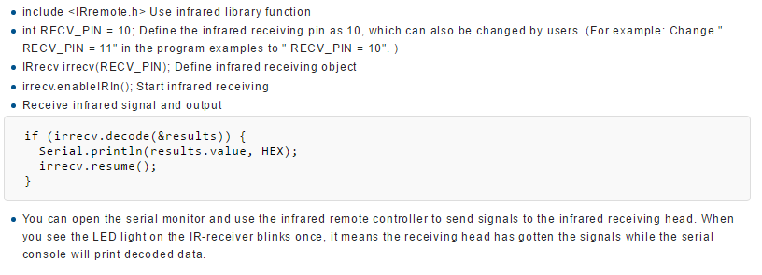
ORIGINAL:
- include <IRremote.h> Use infrared library function
- int RECV_PIN = 10; Define the infrared receiving pin as 10, which can also be changed by users. (For example: Change " RECV_PIN = 11" in the program examples to " RECV_PIN = 10". )
- IRrecv irrecv(RECV_PIN); Define infrared receiving object
- irrecv.enableIRIn(); Start infrared receiving
- Receive infrared signal and output
if (irrecv.decode(&results)) {
Serial.println(results.value, HEX);
irrecv.resume();
}
- You can open the serial monitor and use the infrared remote controller to send signals to the infrared receiving head. When you see the LED light on the IR-receiver blinks once, it means the receiving head has gotten the signals while the serial console will print decoded data.

EDIT:
[ADD Section Title: ] Program Explanation
- #include <IRremote.h> - Imports the IRremote library and allows you to use all functions.
- int RECV_PIN = 10; - Define the pin to which the receiver is connected.
- IRrecv irrecv(RECV_PIN); – Declares an object for the infrared receiver to use IR functions.
- irrecv.enableIRIn(); - Beings the protocol for the sensor to receive infrared signals.
- The code snippet below will print the received signal to the Serial Monitor as it becomes available:
if (irrecv.decode(&results)) {
Serial.println(results.value, HEX);
irrecv.resume();
}

- You can open the Serial Monitor to receive and print data from the infrared transmitter. As a signal is received the LED on the sensor board will blink.

